Electric Circuits & Electronics Design Lab

EE 316-01

# Lab 7&8: BJTs and Amplification Behavior

By: Jaiden Gann

Lab Section 316-01

Lab Date: 7/6/22

Lab Due: 7/12/22

## Introduction:

The purpose of this lab to examine the characteristics and concepts related to BJTs, which later is used to look at MOSFETs. This report will have 5 main sections. First is the theoretical analysis which is done as the pre-lab and includes Multisim simulations. This time there is no handwritten solutions for the circuit. Then we have the physical circuits which are constructed on breadboards in lab. Afterwards, we compare the results from those 3 sections and conclude with an analysis of the results.

## Theoretical Analysis:

To start, we look at how a BJT is constructed and works. It has 3 parts: a collector, base, and emitter regions. The base allows current to flow through the other two parts. There are two types of BJTs: NPN which contains a higher density of electrons in the emitter versus the collector meaning current flows from the collector to emitter and PNP which is the opposite. Current flows through the base but only a small amount comes from the base itself. Maximum current flow is achieved in saturation mode and in cut off mode no current flows. Figure 1 gives the output characteristics of a BJT and Figure 2 shows how current flows through it.

referring to Figure 5, figured out which parts of the wave were contributed by nodes C and D, the DC value of VOUT, and the ripple frequency. This work can be seen in Appendix 1.

**Figure 1**. Output Characteristics of BJTs

**Figure 2.** Current Flow through BJTs

## Simulations:

For the next phase of the lab, we built the circuits shown in Figures 3 and 4 in Multisim. For Figure 3, we were looking at each current(Ib,c,e) for the BJT and then plotting an output characteristic graph.

For Figure 4, we were observing the amplification of the BJT and what the output and gain is at a range of frequencies. We then plotted the gain versus frequency and observed at what values the output is clipped at.

**Figure 3**: Common Collector Circuit

**Figure 4.** Common Collector Circuit (amplification)

## Experimental:

For the last portion of the lab, we did the same things as prior but on a physical board to further validate the output results we obtained. For the first part, we looked at the characteristics output for a BJT. Excel was used for any calculations and plots. As a note, for plotting the VCE fromV1 = 10 was used so that the plot looked better. Table 1 gives the values collected for V1 = 4, 6, 8, and 10. Figure 5 is the characteristic plot. Unlike the simulation we did not measure the current for Ie. Since the saturation point seems to be around 4 mA and because of how we plotted the graph the highest Vce is around 10, the Q-point is around 2.3 mA and 5 volts. For each Ib itself this will vary a bit since we didn’t continue taking data points to match the highest Vce we got from the overall data.

For the second circuit, Table 2 contains the output voltage and gain observed for each frequency. Figure 6 is the plot of gain versus frequency and Figures 7 and 8 and the waveform outputs for the lowest and highest frequencies observed respectively. Figure 9, is a sample output of the waveform at 100k Hz. In lab, the lowest the peak to peak voltage would go for the sine wave was 520-540 mV.

**Table 1.** Data for Ib, Ic, Vce and

|  |  |  |  |  |  |
| --- | --- | --- | --- | --- | --- |
| V1 = 4 | V2 | IB | IC | VCE |  |
|  | 0 | 0.0112 | 0.0104 | 0.0167 | 0.928571 |
|  | 0.4 |  | 0.31 | 0.15 | 27.67857 |
|  | 0.8 |  | 0.6 | 0.18 | 53.57143 |
|  | 0.9 |  | 0.75 | 0.19 | 66.96429 |
|  | 1.1 |  | 0.88 | 0.21 | 78.57143 |
|  | 1.4 |  | 1.2 | 0.25 | 107.1429 |
|  | 1.7 |  | 1.34 | 0.33 | 119.6429 |
|  | 2.5 |  | 1.4 | 1.1 | 125 |
|  | 3 |  | 1.4 | 2.89 | 125 |
| V1 = 6 | 0 | 0.0183 | 0.146 | 0.026 | 7.978142 |
|  | 0.3 |  | 0.25 | 0.13 | 13.6612 |
|  | 0.6 |  | 0.44 | 0.144 | 24.04372 |
|  | 0.9 |  | 0.82 | 0.17 | 44.80874 |
|  | 1.2 |  | 1.02 | 0.18 | 55.7377 |
|  | 1..5 |  | 1.36 | 0.2 | 74.31694 |
|  | 1.8 |  | 1.58 | 0.21 | 86.3388 |
|  | 2.3 |  | 2.04 | 0.26 | 111.4754 |
|  | 2.6 |  | 2.25 | 0.38 | 122.9508 |
|  | 2.9 |  | 2.26 | 0.68 | 123.4973 |
|  | 3 |  | 2.3 | 0.74 | 125.6831 |
| V1 = 8 | 0 | 0.0249 | 0.016 | 0.03 | 0.64257 |
|  | 0.5 |  | 0.44 | 0.13 | 17.67068 |
|  | 1 |  | 0.8 | 0.15 | 32.12851 |
|  | 1.5 |  | 1.35 | 0.18 | 54.21687 |
|  | 1.8 |  | 1.64 | 0.19 | 65.86345 |
|  | 2.2 |  | 2 | 0.21 | 80.32129 |
|  | 2.5 |  | 2.32 | 0.22 | 93.17269 |
|  | 2.9 |  | 2.67 | 0.25 | 107.2289 |
|  | 3.3 |  | 3.1 | 0.32 | 124.498 |
|  | 3.7 |  | 3.11 | 0.62 | 124.8996 |
|  | 4.3 |  | 3.12 | 1.18 | 125.3012 |
|  | 4.8 |  | 3.14 | 1.75 | 126.1044 |
|  | 5.6 |  | 3.15 | 2.4 | 126.506 |
|  | 7.7 |  | 3.2 | 4.56 | 128.5141 |
| V1 = 10 | 0 | 0.0317 | 0.02 | 0.0327 | 0.630915 |
|  | 1 |  | 0.87 | 0.14 | 27.44479 |
|  | 2 |  | 1.84 | 0.188 | 58.04416 |
|  | 2.3 |  | 2.11 | 0.209 | 66.56151 |
|  | 2.9 |  | 2.77 | 0.21 | 87.3817 |
|  | 3.2 |  | 3 | 0.23 | 94.63722 |
|  | 3.5 |  | 3.29 | 0.24 | 103.7855 |
|  | 4.4 |  | 3.9 | 0.53 | 123.0284 |
|  | 5.7 |  | 4 | 1.78 | 126.183 |
|  | 7.9 |  | 4.05 | 3.9 | 127.7603 |
|  | 9.7 |  | 4.09 | 5.63 | 129.0221 |
|  | 10.4 |  | 4.11 | 6.3 | 129.653 |
|  | 10.7 |  | 4.12 | 6.6 | 129.9685 |
|  | 11.8 |  | 4.144 | 7.79 | 130.7256 |
|  | 12.5 |  | 4.154 | 8.39 | 131.041 |
|  | 13.3 |  | 4.15 | 9.23 | 130.9148 |
|  | 14 |  | 4.2 | 9.8 | 132.4921 |



**Figure 5.** Output Characteristics

**Table 2.** Amplification observations

|  |  |  |
| --- | --- | --- |
| F(HZ) | VOUT | Gain(db) |
| 10 | 0.006 | -38.757 |
| 30 | 0.07 | -17.4181 |
| 60 | 0.072 | -17.1734 |
| 100 | 0.084 | -15.8345 |
| 200 | 0.096 | -14.6746 |
| 1k | 0.101 | -14.2336 |
| 2k | 0.113 | -13.4239 |
| 5k | 0.137 | -11.7511 |
| 10k | 0.221 | -7.91941 |
| 15k | 0.39 | -2.98596 |
| 20k | 0.57 | 0.310243 |
| 50k | 0.78 | 3.034638 |
| 75k | 1.85 | 10.53618 |
| 100k | 2.69 | 13.78779 |
| 150k | 3.46 | 16.13365 |
| 200k | 4.9 | 19.15605 |
| 500k | 5.6 | 20.31589 |
| 750k | 6.4 | 21.47572 |
| 1M | 6.4 | 21.47572 |
| 1.5M | 6.4 | 21.47572 |
| 2M | 6.4 | 21.47572 |

**Figure 6.** Gain vs Frequency

**Figure 7.** Lowest Frequency Waveform

**Figure 8.** Highest Frequency Waveform

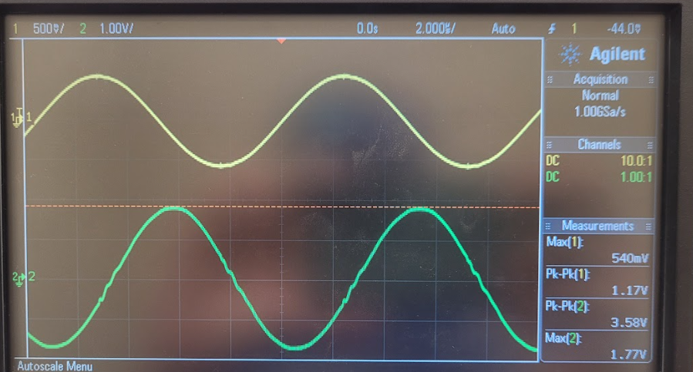

**Figure 9.** Waveform at 100k Hz

## Results and Discussion:

The results of this lab were pretty in line with what we expected. The simulation data taken during prelab was wrong for the first part of the lab where we were looking at output characteristics of a BJT, due to not understanding how to increment V2 and the proper way to get Vce. However, the experimental portion was done correctly, the output lines more closely match what we were looking for. The second portion of the lab, where we were observing amplification with the BJT, did match our expectations and pre-lab results. However, in pre-lab the wrong thing was plotted on accident and the gain differed. However, this was a mistake in doing the equation wrong and both gain results still exhibited the same behavior of starting out really small and then increasing until it eventually clips and remains constant.

For the first portion, since the saturation point seems to be around 4 mA and because of how we plotted the graph the highest Vce is around 10, the Q-point is around 2.3 mA and 5 volts. For each Ib itself this will vary a bit since we didn’t continue taking data points to match the highest Vce we got from the overall data. For the second portion, around 200k Hz is when we start to see the output start to clip.

## Conclusion

Overall, the results of lab where in line with what we expected from the information gathered from the theoretical sections. Our results matched the characteristic trends in the data for the simulation and experimental portions, even though the actual data itself was written down wrong the simulation. It showed us what we should see as far as output, gain, waveforms, and current flow in a BJT which will be useful when we do MOSFETS. All together the lab gave us a better understanding of BJTs.

## Appendix 1:

N/A

## Appendix 2:

Signed lab results

Pictures of Circuits

Figure 1. Common Collector Circuit (ref Figure 3)

**Figure 2.** Common Collector Amplification (ref Figure 4)